**Listings**

Create

uri: http://127.0.0.1:8000/listings/create

type: post

json body: (see above)

* Remember to set is_active to true so this listing is “active”

response: (see above)

used for: creating new listings

behaviours: all fields are required (will give an error message if missing)

**front end implementation**: on success, redirect user to main page (? Somewhere that makes sense)

Update

uri: http://127.0.0.1:8000/listings/update/<listing_id>/

-note: the include the slash at the end, Django will check for this

type: put

json body: (see above, just include the fields that need to be updated, you can check previous page for available fields)

response: (see above)

used for: updating listing

behaviours: throws error if id does not exist, not all fields are required (include only ones that need to be updated)

**front end implementation**: on success, redirect user to main page (? Somewhere that makes sense)

Remove (this sets is_active field to false, we don’t delete it so user can still see the listing in order history)

uri: http://127.0.0.1:8000/listings/remove/<listing_id>/

-note: the include the slash at the end, Django will check for this

type: post

json body: empty

response: (see above)

used for: removing listing

behaviours: throws error if id does not exist, listing is not deleted, is_active is set to false

**front end implementation**: on success, redirect user to main page (? Somewhere that makes sense)

GetActiveListings (listing count>0 and is_active=true)

uri: http://127.0.0.1:8000/listings/get/active

type: get

json body: -

response: (see above, i included seller details for displaying on the FE, seller_id also will be used in checkout api)

used for: show all listings

**front end implementation**: -

GetSellerListings

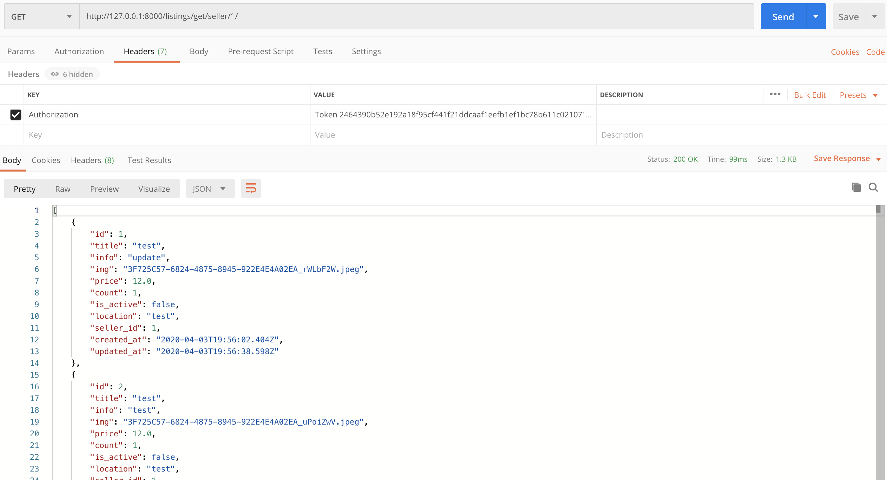

uri: http://127.0.0.1:8000/listings/get/seller/<seller_id>/

-note: the include the slash at the end, Django will check for this

-seller_id is stored in cache (same as user_id)

type: get

json body: -

response: (see above)

used for: getting user’s listings

behaviours: throws error if id does not exist

**front end implementation**: there can be a page that shows items being sold by the user, from there you can update/delete the listings (this api provides the listing_id needed by update/delete)

GetListing

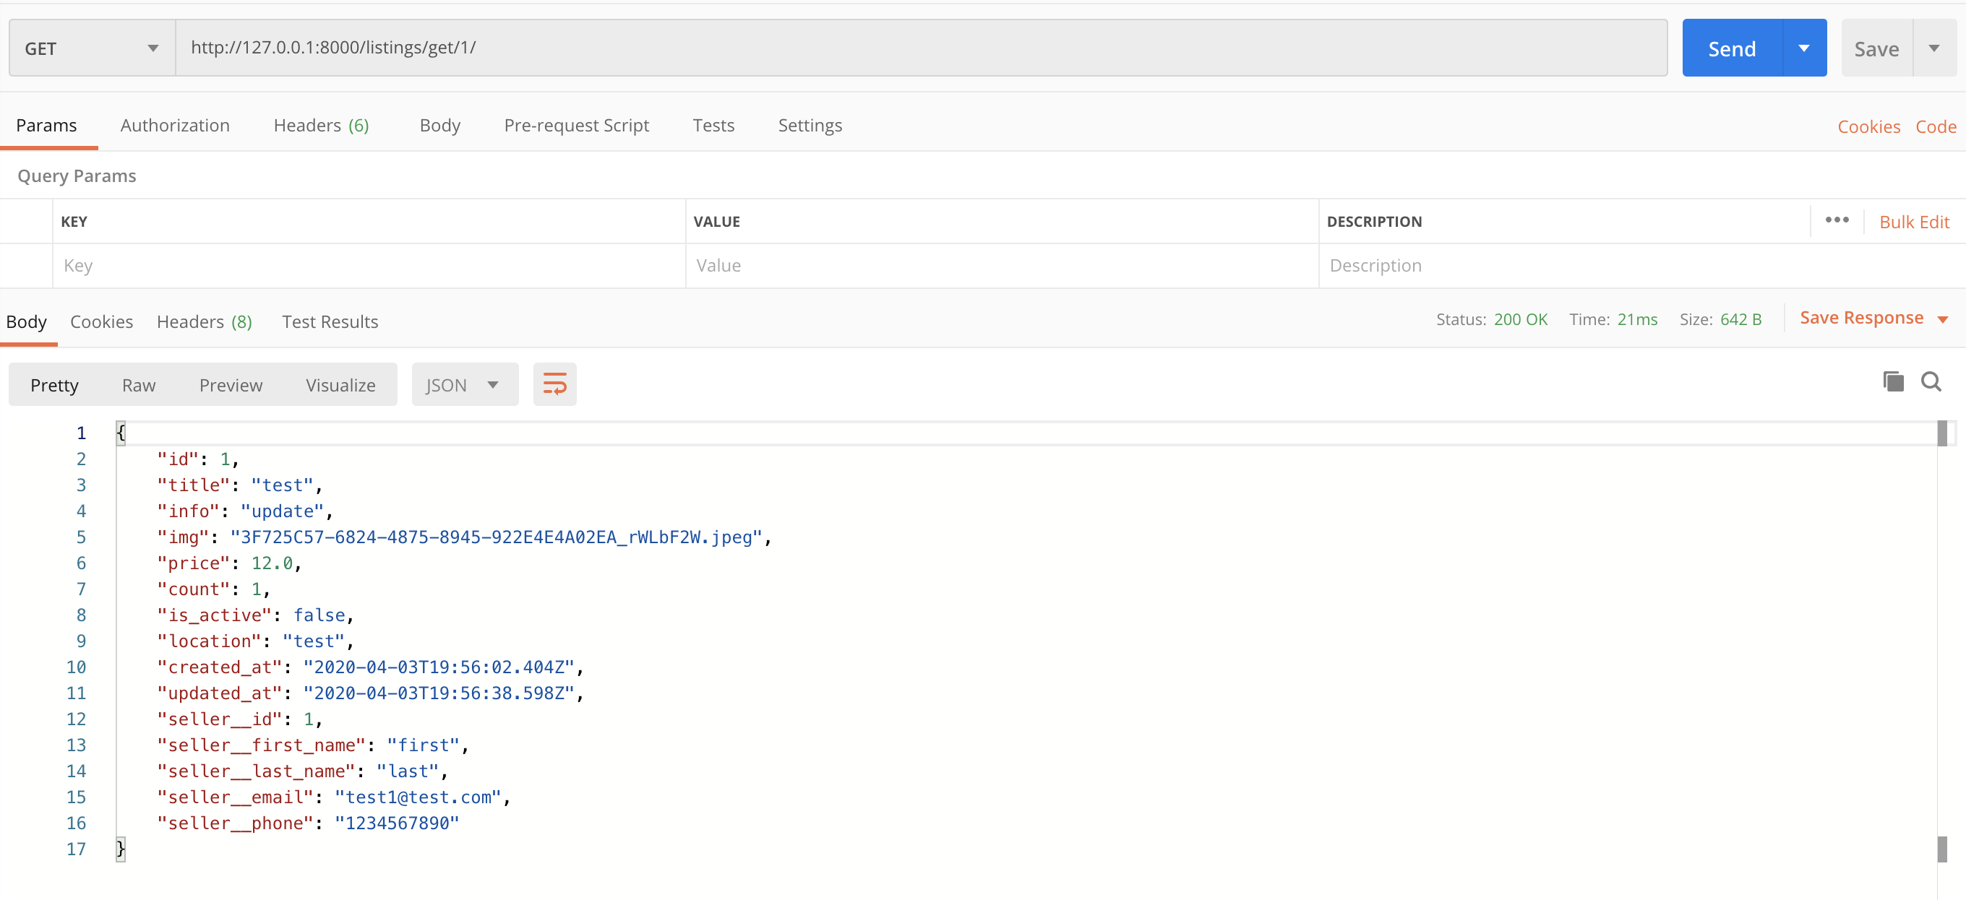

uri: http://127.0.0.1:8000/listings/get/<listing_id>/

-note: the include the slash at the end, Django will check for this

type: get

json body: -

response: (see above)

used for: getting listing by listing id

behaviours: throws error if id does not exist

**front end implementation**: if we create a details page you can use this api to get the listing details (probably from the order history page ?)